|  |  |  |  |
| --- | --- | --- | --- |
|  | | | |
| **Expt. No:** | | **5** | **V-I Characteristics of PN – Junction Diode** |
|  | | |
| **Date:** | **10/09/2020** | |
|  | | | |

**Aim:**  To obtain and plot both forward and reverse characteristics of PN – Junction Diode.

**SOFTWARE TOOLS / OTHER REQUIREMENTS:**

1. Multisim Simulator/Circuit Simulator
2. PN Diode
3. Resitor (1K)
4. Variable DC Supply

# Theory:

The semiconductor diode is formed by doping P-type impurity on one side and N-type of impurity on other side of the semiconductor crystal forming a p-n junction as shown in the following figure.

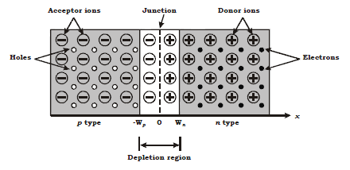

At the junction initially free charge carriers from both side recombine forming negatively charged ions in P side of junction(an atom in P-side accept electron and becomes negatively charged ion) and positively charged ion on n side(an atom in n-side accepts hole i.e. donates electron and becomes positively charged ion)region. This region deplete of any type of free charge carrier is called as depletion region. Further recombination of free carrier on both side is prevented because of the depletion voltage generated due to charge carriers kept at distance by depletion (acts as a sort of insulation) layer as shown dotted in the above figure.

When voltage is not applied across the diode, depletion region is formed as shown in the above figure. When the voltage is applied between the two terminals of the diode (anode and cathode) two possibilities arise depending on polarity of DC supply.

1. Forward-Bias:

When the +Ve terminal of the battery is connected to P-type material & -Ve terminal to N-type terminal as shown in the circuit diagram, the diode is said to be forward biased. The application of forward bias voltage will force electrons in N-type and holes in P-type material to recombine. This reduces width of depletion region. This further will result in increase in majority carriers flow across the junction. If forward bias is further increased in magnitude the depletion region width will continue to decrease, resulting in exponential rise in current as shown in ideal diode characteristic curve.

1. Reverse-biased:

If the negative terminal of battery (DC power supply) is connected with P-type terminal of diode and +Ve terminal of battery connected to N type then diode is said to be reverse biased. In this condition the free charge carriers (i.e. electrons in N-type and holes in P-type) will move away from junction widening the depletion region width. The minority carriers (i.e. –ve electrons in p-type and +ve holes in n-type) can cross the depletion region resulting in minority carrier current flow called as reverse saturation current(Is). As no of minority carrier is very small so the magnitude of Is is few microamperes. Ideally current in reverse bias is zero.

In short, current flows through diode in forward bias and does not flow through diode in reverse bias. Diode can pass current only in one direction.

**CIRCUIT DIAGRAM:**

Forward bias:

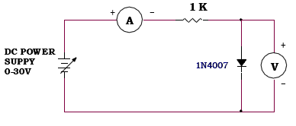

Reverse bias:

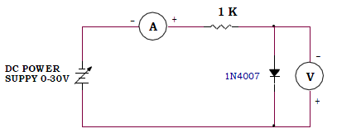

**forward characteristics:**

**Circuit/connection diagrams (fROM simulator)**

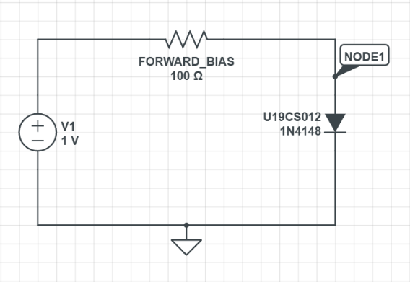

**VI-plot (fROM simulator/graph)**

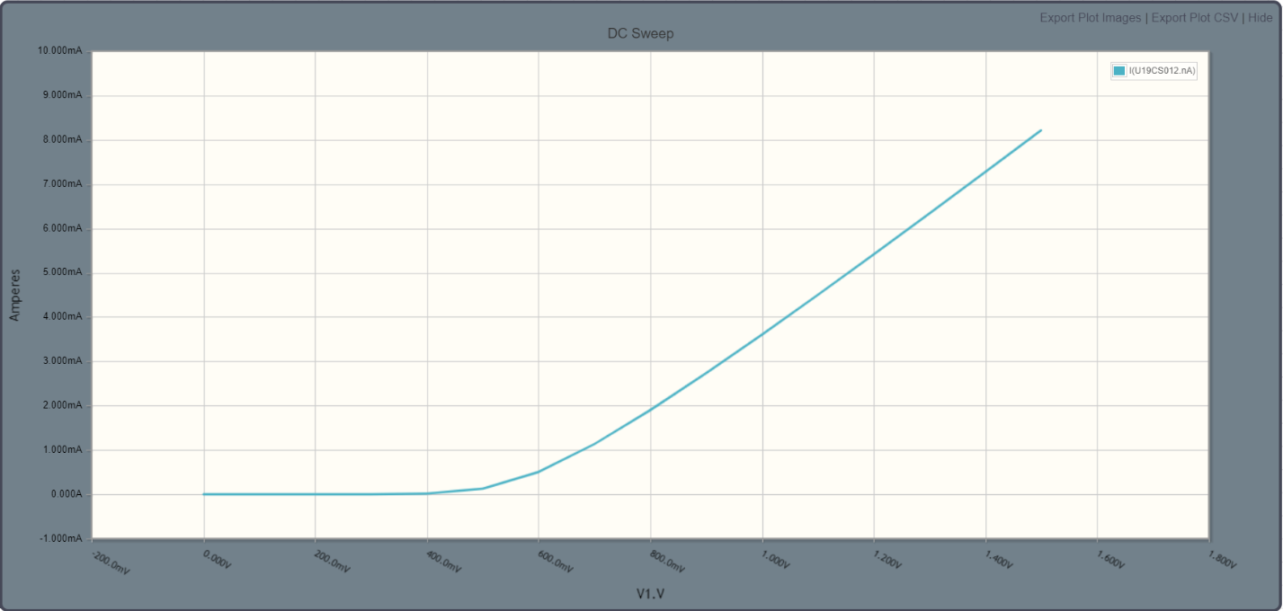

**reverse characteristics:**

**Circuit/connection diagrams (fROM simulator)**

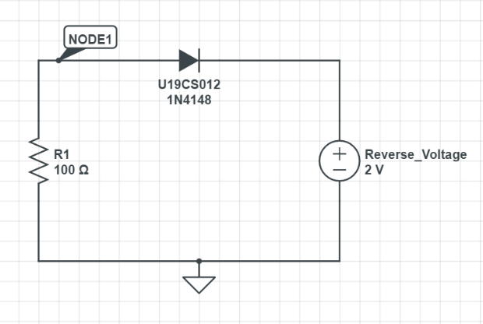

**VI-plot (fROM simulator/graph)**

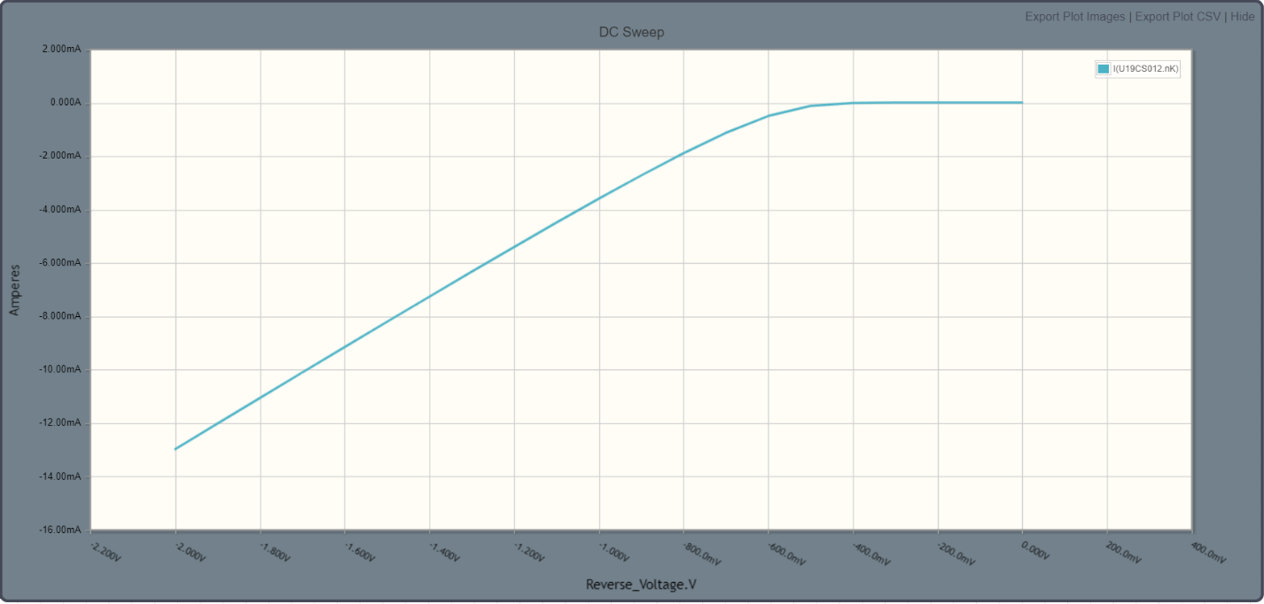

**Conclusions**

# 1.) The I-V Characteristics of Simple Diode in Forward and Reverse Bias have been Verified Practically with above Graphs with Theoretical Knowledge.

**ASSIGNMENT-5**

U19CS012

**1.** Obtain and Plot the forward and reverse characteristics of ZENER Diode in *LabOnline* Simulation Environment.

A.) Forward Characteristics of ZENER Diode

*1.) Circuit Image:*

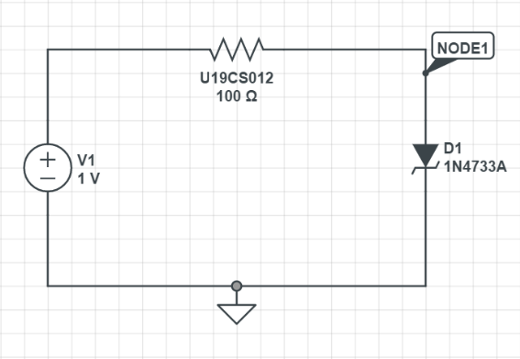

*2.) Graph:*

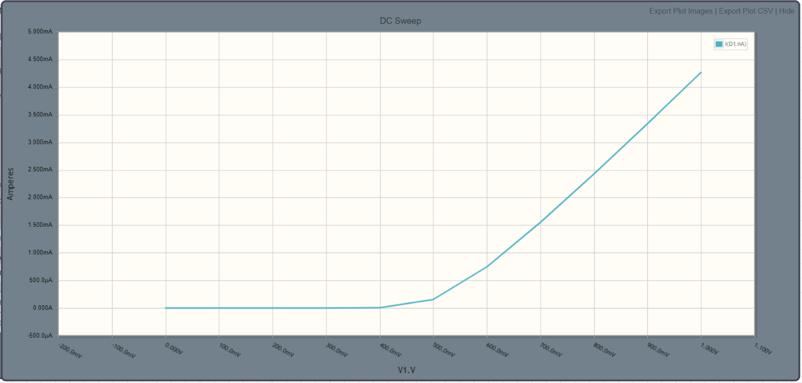

*3.) Explanation:*

*In Forward Bias, ZENER Diode Follows the Same I-V Characteristic Curve as Simple Diode in Forward Bias. Forward Voltage = 0.5 Volts*

B.) Reverse Characteristics of ZENER Diode

*1.) Circuit Image:*

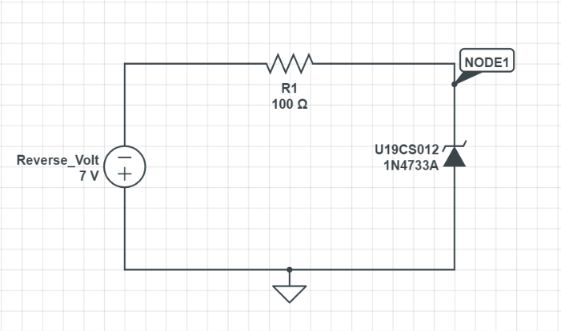

*2.) Graph:*

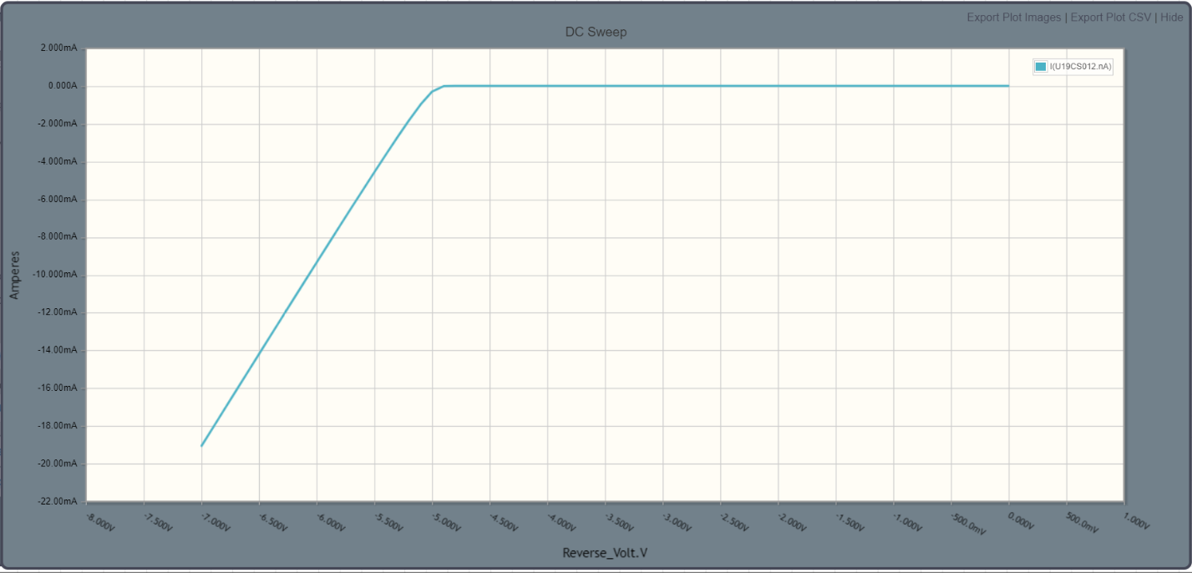

*3.) Explanation:*

In Reverse Bias, ZENER Diode Does not follows the Same I-V Characteristic Curve as Simple Diode in Reverse Bias, Instead a Sharp Drop in Current is observed. This is Called ZENER Breakdown Voltage.

Breakdown Voltage = -5 Volts

*C.) Conclusion:*

ZENER Diode I-V Characteristics have been Practically Verified through this Simulation with the Theoretical Knowledge. Hence Experiment was Performed Successfully. [Without Error]